Paving the Way Towards Better Curb Appeal
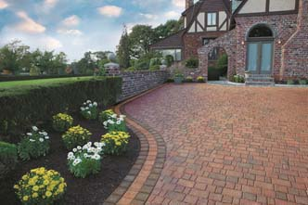Today, driveways are considered part of the landscaping and upgrading them can improve a home’s curb appeal.
Curb appeal. It’s that good impression that a prospective buyer receives when looking at a home for purchase. It starts at the curb before the buyer even walks into the home.
As more homeowners recognize the value of improving such first impressions, there’s a growing interest in landscaping—with plantings, stonework and the creation of points of interest, such as fountains or enclosed spaces. As some designers have said, “the garden is the new kitchen.”
Lately, the desire to improve curb appeal has also meant the creation of a distinctive driveway. Treating the driveway as part of the landscaping is one of the hottest new design trends.
An increasingly popular driveway design choice is also a practical one: concrete pavers.
Many homeowners consider concrete pavers a more attractive and permanent solution than asphalt—an important investment in improving their home’s curb appeal. Pavers are easier to maintain and last longer without needing to be repaired.
For a prospective buyer, the driveway suggests how a home is maintained. If buyers see an immaculate driveway, they assume everything they can’t see in the home might also be well maintained.
Real estate experts say it’s easy to recoup the cost of a driveway upgrade. In fact, it may be doubly recouped when you sell the house.
Pavers provide a safe, slop resistant surface in beautiful beige, coral, multi-colored or darker blended colors, as well as blends with flashed tones to harmonize with a home’s exterior cladding.
Other effective ways to enhance your home’s curb appeal include:
- Patios: A well-designed patio made of interlocking concrete pavements can enhance the character of your home and provide extra entertaining space.
- Pool decks: Concrete pavers are an excellent way to integrate the pool visually into your landscaping design.
- Walkways: A properly paved walkway can frame your home. To lend more grace to an entrance, walkways should be at least three feet wide and gently curved.
- Lighting: At night, lighting can increase safety and add ambiance in patios, walkways and driveways.
For more information about concrete pavers, visit the Interlocking Concrete Pavement Institute website at www.icpi.org.

