Pave Your Way to a More Beautiful Home

When you get down to it, the driveway, front walk, steps, patio and other pathways leading to your home are among the best ways to make a good first impression on guests, prospective buyers and yourself, every time you come home.
As an increasing number of homeowners are discovering, the best materials for such things may be concrete pavers.
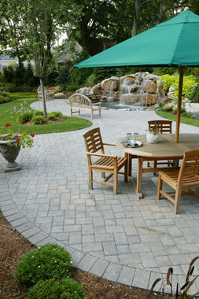
Concrete pavers can be a beautiful way to enhance your home.
There are several reasons. Concrete pavers:
- Are beautiful. They come in many shapes and colors. Suppliers stock rustic stone-like pavers and other that like clay brick. Light colored pavers can offer a cooler surface around patios and pool decks.
- Don’t crack like asphalt or poured-in-place concrete. Each unit has joints that allow for a small amount of movement without cracking.
- Are easy to repair. You can remove and reinstate the same pavers with no ugly patches after repairs to the base or underground utilities. Other pavements can’t make this claim.
- Resist deterioration from freeze-thaw cycles and deicing salts better than other surfaces. Snow removal is the same as with other pavements. Interlocking concrete pavements can even accommodate snow melting systems. These consist of hot water filled tubing or radiant wires placed right in the pavement. They turn on automatically when a snowstorm starts, eliminating plowing, ice hazards and the need for de-icing salts.
- Resist oil and antifreeze that leak from cars, making the pavers particularly good for driveways.
- Can accommodate lighting fixtures that fit right into the paver pattern. These systems include wiring and a transformer that plug into a standard 110-volt outdoor receptacle. The lighting defines patios, walkways, and driveways at night, increasing safety and adding a bit of mystique to your home.
- Can define and enlarge space for planting beds.
- Can be installed by a professional or a skilled do-it-yourselfer.
Most concrete paver suppliers can supply printed step-by-step instructions for patios and walkways, as well as help do-it-yourselfers locate the tools and other materials required. It’s a good idea to hire a contractor for driveways and areas larger than 300 square feet.
Professional contractors can complete a high-quality job quickly and safely because they have the right equipment and materials. In addition, when you use an ICPI Certified Installer, you know the project is built according to industry guidelines.
The ICPI offers a free online consumer guide to help you choose a contractor, learn the installation basics of a good interlocking concrete pavement system and know what to expect during the delivery, set-up and installation of your segmental pavement project. Visit us at www.icpi.org.

