Increase Your Homes Curb Appeal and Help Protect the Environment

Homeowners can not only help protect the environment they can improve the curb appeal of their home with interlocking concrete pavement. Interlocking concrete pavement (ICP) is not only visibly appealing it lasts longer than other conventional pavements such as poured concrete or asphalt. A study by Applied Research Associates (ARA) finds life-cycle costing for Interlocking Concrete Pavements is 29 years. This is longer than other conventional pavements.
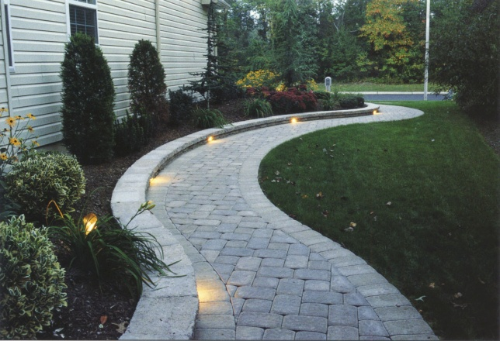 Interlocking concrete pavements not only look good they last longer.

This ability to last longer makes ICP the sustainable pavement of the future. Sustainable means using methods, systems and materials that won't deplete resources or harm natural cycles. Interlocking concrete pavement’s longer life-cycle means less of an impact on resources. Every homeowner can do their part to protect the earth with the use of sustainable products around the home. An added plus for the homeowner with ICP is less maintenance and repair and it looks great!
Pavers are visually appealing
Pavers can be used for walks, patios and driveways, as well as for parking lots and residential streets. Homeowners particularly like the vast array of colors, shapes, sizes and textures available. You can get rustic stone like pavers or others that look like clay brick. In the warmer months light-colored pavers can provide a cooler surface around patios and pool decks. When it gets cold these pavers are easy to snowplow and they work well in freeze-thaw environments.
You can learn more about interlocking concrete pavements and find an experienced, professional installer by visiting the Interlocking Concrete Pavement Institute’s Web site at www.icpi.org.

