For More Living Space, Outdoor Kitchens Are In
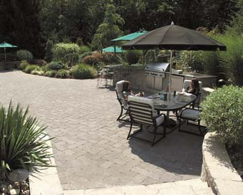
A taste for the outdoors—an outdoor patio kitchen becomes a gathering place for family and friends.
When the real estate market it tight and homeowners still need more living space, may turn their sites outdoors.
That is why many homeowners are putting a backyard outdoor kitchen on their front burners. Beauty and economy are just two of the reasons. When constructed on a paver patio, it becomes the least expensive room addition at approximately $10 to $15 per square foot for a new room addition.
Among the other advantages of pavers is that when they are finished, they look very much like elegant tiles or cut stone. They don’t crack and come in many, shapers, colors and textures.
Also popular in the backyard are fire pits, fireplaces and hot tubs. All of which are easy on the budget compared to indoor improvements.
Interlocking concrete pavers are also popular in the front of the home. For walkways and driveways, they are one of the most versatile and customizable options. Homeowners may be glad to know that pavers resist deterioration from deicing salts and harsh climatic changes better than other pavements.
For many homeowners, however, it’s the vast array of colors, shapes, sizes and textures that make concrete pavers such a popular option for any project that demands character and personality. In addition, the pavers are easy to install, and should they need repair, it’s easily done.
These types of home improvements not only make the home more livable, they can help to maintain or even increase the home’s value when it comes time to sell.
For more design ideas and to find an ICPI Certified Installer, visit the Interlocking Concrete Pavement Institute website at www.icpi.org.

