Adding Style and Flexibility to Your Landscaping

Many homeowners desire the high-end look of stone on their property’s walks and driveways at more modest concrete prices.
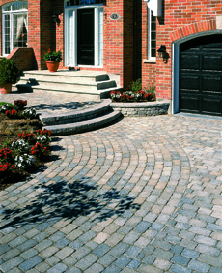
Using interlocking concrete pavers to create an exciting, durable driveway relies on a technique that the Romans used to build their roads.
One way to do this is with interlocking concrete pavers—a pavement type that is growing in popularity. Also called segmental paving, the basic technique is as classic as the roads of the Roman empire. Interlocking concrete pavers use high-strength, durable concrete units that interlock together to form a patterned surface which can be put into service immediately.
Pavers are manufactured in various shapes, textures and colors. A big benefit of pavers is that they can be removed and reinstalled, which reduces future service interruptions.
They are often used in walkways, patios, driveways, plazas and downtown renovations.
Concrete pavers are available in a wide range of styles. For instance, one is crafted to resemble roman paving stones.
Paver units are often used in historic restoration projects, such as streets in historic areas. Since paver units are uniform in size, they offer a smoother ride and are easier to repair than their historic cobblestone counterpart.
The popularity of pavers in expanding rapidly in the United States and Canada. There is plenty of growth to go; in Europe there are 10 square feet of pavers installed per person annually, however, in North America it is just under two square feet per person. In the Netherlands, most of the streets and sidewalks are pavers.
Dayton, Ohio and Toronto, Ontario are two of many cities that have used concrete pavers in historic neighborhoods to enhance the area’s image and support the investment by residents in their homes.
The ability to produce pavers in a wide variety of shapes and colors makes it possible to use them in colorful, attention-grabbing ways that can add to the character of the home. For example, Overtown, Florida created an urban park that used pavers in patterns and colors take from Kente Cloth, a non-repetitive weave from North Africa.
To learn more about using concrete pavers in a patio or driveway, visit the Interlocking Concrete Pavement Institute website at www.icpi.org.

